

**training support system**

**Software Requirement Specification**

– Hanoi, September 2022 –

***Record Of Changes***

| **Date** | **A* M, D** | **In charge** | **Change Description** |
| --- | --- | --- | --- |
| 10/Sep | A | DatLT | Overview Introduction: Summary PJ, Context Diagram |
| 10/Sep | A | AnhPT | Add 2.c User authorization |
| 10/Sep | A | DaiNH | Add 2.a Screen Flow |
| 11/Sep | M | DaiNH | Update 2.a Screen Flow |
| 11/Sep | A | DaiNH | Add 2.b Screen Details |
| 11/Sep | A | HoangL | Entity Relationship Diagram |
| 18/Sep | A | AnhPT | Add functional requirement for Change Password, Setting List and Setting Detail screen |
| 18/Sep | A | DatLT | Add functional requirement for User List, User Detail |
| 18/Sep | A | DatLT | Add Web Contact List |
| 18/Sep | M | DatLT | Context Diagram |
| 18/Sep | M | KyNVC | Modified II - 2. User |
| 18/Sep | A | KyNVC | Add II - 1. Account |
| 18/Sep | M | AnhPT | Update functional requirement of Setting List and Setting Detail screen |
| 18/Sep | A | HoangL | Add functional requirements for Home Page, Demo Dashboard and User Profile |
| 18/Sep | A | DaiNH | Add screen for Web Contact Details, Subject List and Subject List Details  Write functional requirement for Web Contact Details, Subject List and Subject List Details |
|  |  |  |  |
|  |  |  |  |
|  |  |  |  |
|  |  |  |  |
|  |  |  |  |
|  |  |  |  |
|  |  |  |  |
|  |  |  |  |
|  |  |  |  |
|  |  |  |  |
|  |  |  |  |
|  |  |  |  |
|  |  |  |  |
|  |  |  |  |
|  |  |  |  |

*\*A - Added M - Modified D - Deleted*

**Table of Contents**

I. Overview **4**

1. Introduction 4

2. System Functions 5

a. Screen Flow 5

b. Screen Details 5

c. User Authorization 6

d. Non-Screen Functions 6

3. Entity Relationship Diagram 7

**II. Functional Requirements** **9**

1. Account 9

1.1 Login 9

1.2 Register 9sss

1.3 Reset password 10

2. User 11

2.1. User List 11

2.2. User Details 12

2.3. Change Password 12

2.4. Setting list 13

2.5. Setting detail 14

3. Web Contact 15

3.1 Web Contact List 15

3.2. Web Contact Details 15

# I. Overview

## 1. Introduction

*The Training Support System is a software that creates an online learning environment for students. Here, students will learn completely online on the web under the guidance of a mentor without having to go to school. The learning content is guaranteed to be close to the traditional way of learning along with all the necessary materials of the course, if you have any questions, you can message directly to the permanent supporters. In addition to the variety of online courses, you can take any course you want and pay via the Internet. And the system can continuously monitor the learning progress as well as the scores, thereby making the learning of students and mentors more effective.*

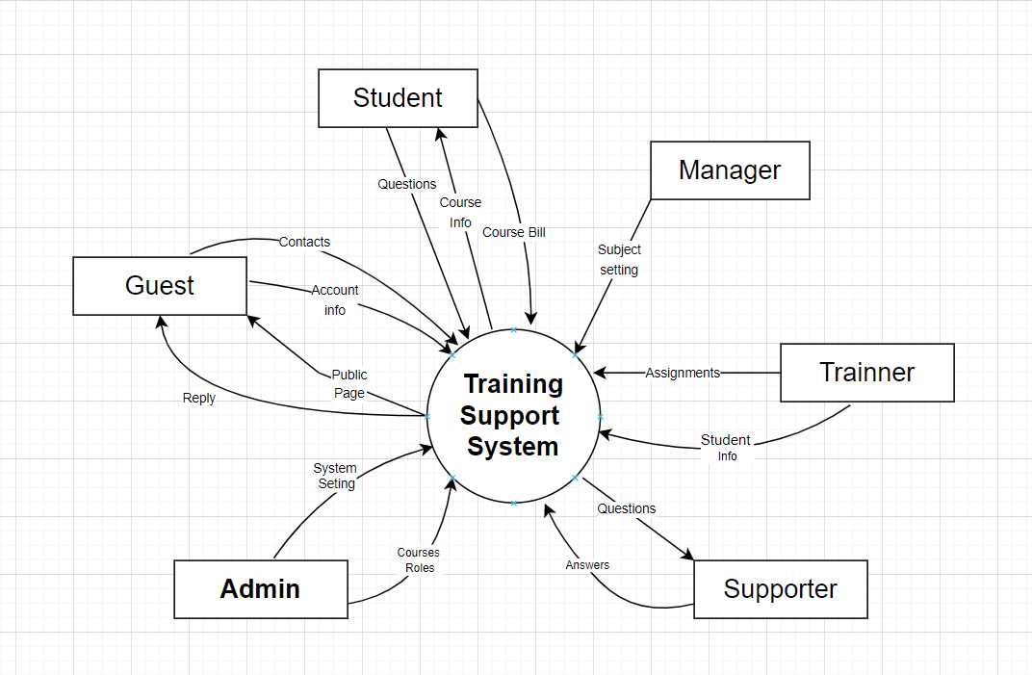

## 2. System Functions

#### a. Screen Flow

*[This part shows the system screens and the relationship among screens. You can draw the Screens Flow for the system in the form of diagram as below]*

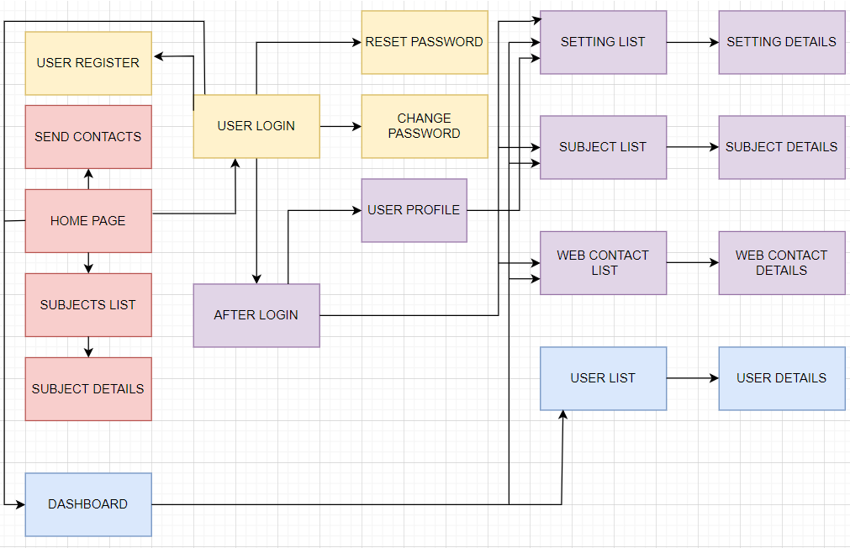

#### b. Screen Details

*[Provide the descriptions for the screens in the Screens Flow above]*

| **#** | **Feature** | **Screen** | **Description** |
| --- | --- | --- | --- |
| 1 | Order subject | Subject list, subject details | After login, the homepage displays the subject list, and customers can order or view details by clicking the button. |
| 2 | Register | User register | Customers register a new account. |
| 3 | Reset password | User login | Click the button to reset the password if customers forgot their password. |
| 4 | Change password | Change password | Input some information like account, mail, old password and new password to change. |
| 5 | View profile and setting account | User profile | Customers can view their information, and change it. |
| 6 | View dashboard and setting all | Dashboard | After login by admin account, viewing dashboard and change setting. |
| 7 | Send contact | Send contact | Form is on the homepage, it can be sent by guest account. |

#### c. User Authorization

| **Screen** | **Guest** | **Student** | **Admin** | **Manager** | **Expert** | **Trainer** | **Supporter** |
| --- | --- | --- | --- | --- | --- | --- | --- |
| Home Page | X | X | X | X | X | X | X |
| Dashboard |  |  | X | X | X | X |  |
| User Login |  | X | X | X | X | X | X |
| Password Reset |  | X | X | X | X | X | X |
| User Register | X |  |  |  |  |  |  |
| User Profile |  | X | X | X | X | X | X |
| -View profile |  | X | X | X | X | X | X |
| -Edit profile |  | X | X | X | X | X | X |
| Password Change |  | X | X | X | X | X | X |
| Setting List |  |  | X |  |  |  |  |
| -View/Edit setting |  |  | X |  |  |  |  |
| -Activate/Deactivate setting |  |  | X |  |  |  |  |
| Setting Details |  |  | X |  |  |  |  |
| User List |  |  | X |  |  |  |  |
| -View/Edit user |  |  | X |  |  |  |  |
| -Activate/Deactivate user |  |  | X |  |  |  |  |
| User Details |  |  | X |  |  |  |  |
| Subject List |  |  | X | X | X | X |  |
| -View/Edit subject |  |  | X | X | X | X |  |
| -Activate/Deactivate subject |  |  | X | X |  |  |  |
| Subject Details |  |  | X | X | X | X |  |
| Web Contact List |  |  | X |  |  |  | X |
| -View/Edit web contact |  |  | X |  |  |  | X |
| Web Contact Details |  |  | X |  |  |  | X |

In which:

* **Guest**: Unlogin user, has access to the Home Page & other public pages
* **Student**: Can attend classes, enroll courses and take lessons in the system
* **Admin**: Have full authority. Can configure the system, managing the subject list and authorizing subject management.
* **Manager**: Monitor, configure and implement the subjects they are in charge of. Also act as Expert/Trainer
* **Expert**: Prepare training content for subjects. Also act as Trainer
* **Trainer**: Student management, student assignment project implementation.
* **Supporter**: Preparing news articles, answering questions/web contacts, tracking orders, user support.

#### d. Non-Screen Functions

| **#** | **Feature** | **System Function** | **Description** |
| --- | --- | --- | --- |
| 1 | Mailtrap.io | Email related function | The system will use Mailtrap.io api for all the email related function |
| 2 | Logging | System event logs | The database system logs all transactions that change application data or the database catalog in log entries |

## 3. Entity Relationship Diagram

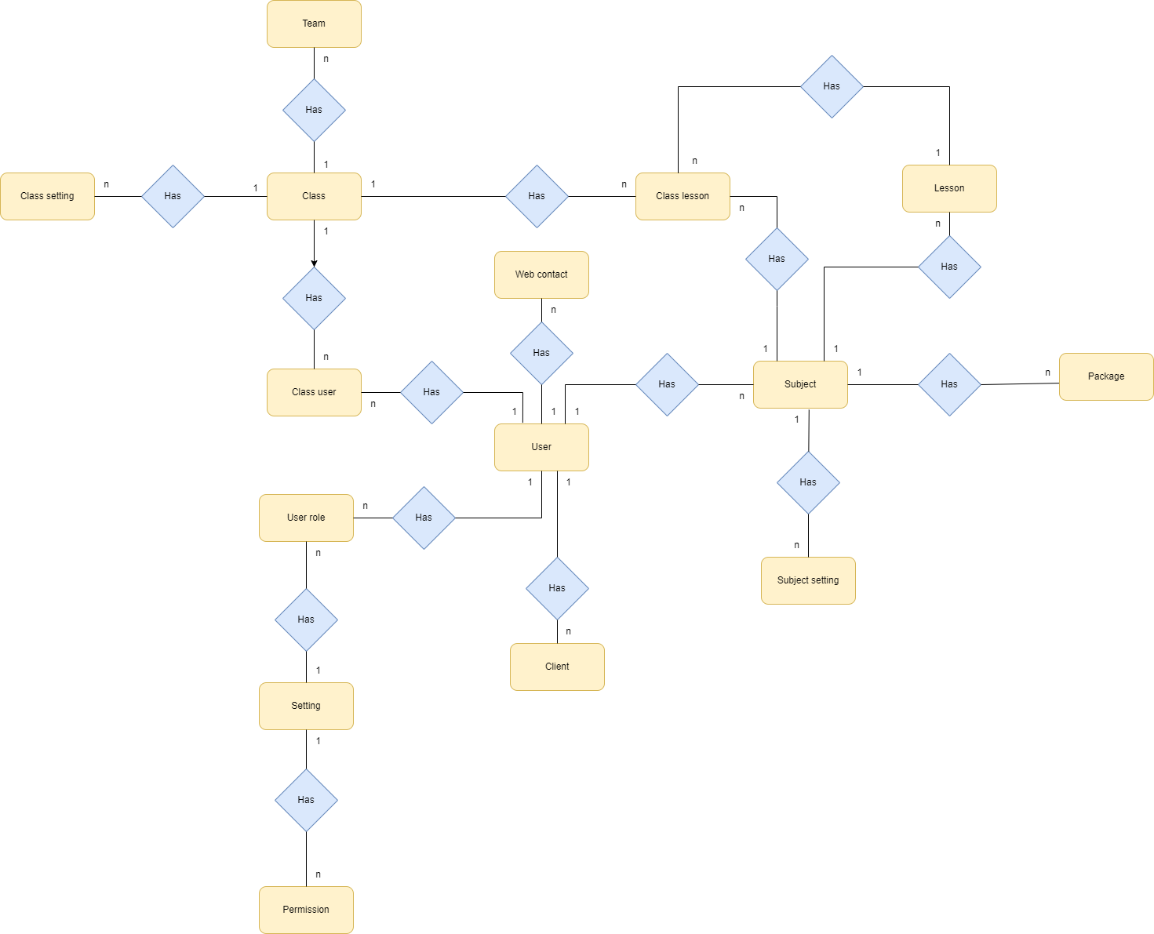

**Entities Description**

| **#** | **Entity** | **Description** |
| --- | --- | --- |
| 1 | Class setting | The setting of class |
| 2 | Class | The information of class |
| 3 | Team | The information of team |
| 4 | Class user | The member of class |
| 5 | User role | The role of user |
| 6 | Setting | The setting functions |
| 7 | Permission | The permission of user |
| 8 | Web contact | The information of web of user |
| 9 | User | The information of user |
| 10 | Client | The information of client |
| 11 | Class lesson | The information of lesson of class |
| 12 | Subject | The information of subject |
| 13 | Subject setting | The setting of subject |
| 14 | Lesson | The information of lesson |
| 15 | Package | The information of package |

# 

# 

# 

# 

# 

# 

# II. Functional Requirements

## 1. Account

### 1.1 Login

**Function trigger:** Click the Login button or redirect from other pages if the user is not logged in.

**Function description:** The system will check the user account and password and allow the user to log in if the account and password are correct. If the account and password are incorrect, the system will display an error message.

If the account and password are correct, the system will redirect to the homepage.

Otherwise, the system will display the error message.

**Screen layout:**

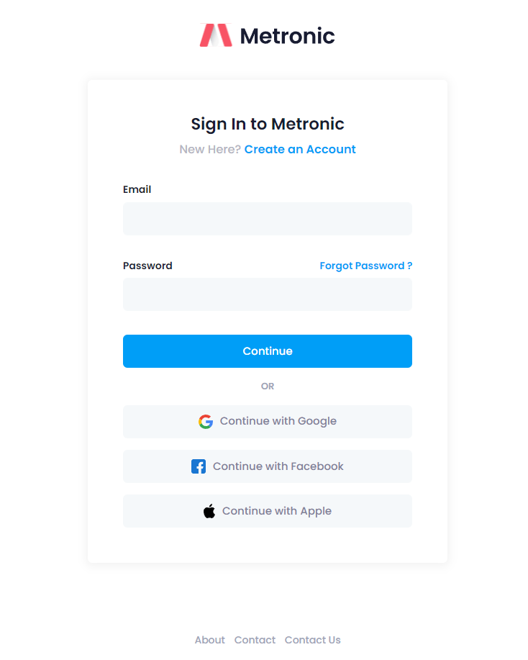

**Function Details:** Show the form to input the account and password.

After the user clicks the Login button, the system will request POST /login to check the account and password.

if the account and password are correct, the system will respond with 200 and JSON data.

Otherwise, the system will respond to 400 and JSON data.

if data is 200, the system will redirect to the homepage and allow the user to access the system.

### 1.2 Register

**Function trigger:** Click the Register button

**Function description:** Allows the user to register a new account.

**Screen layout:**

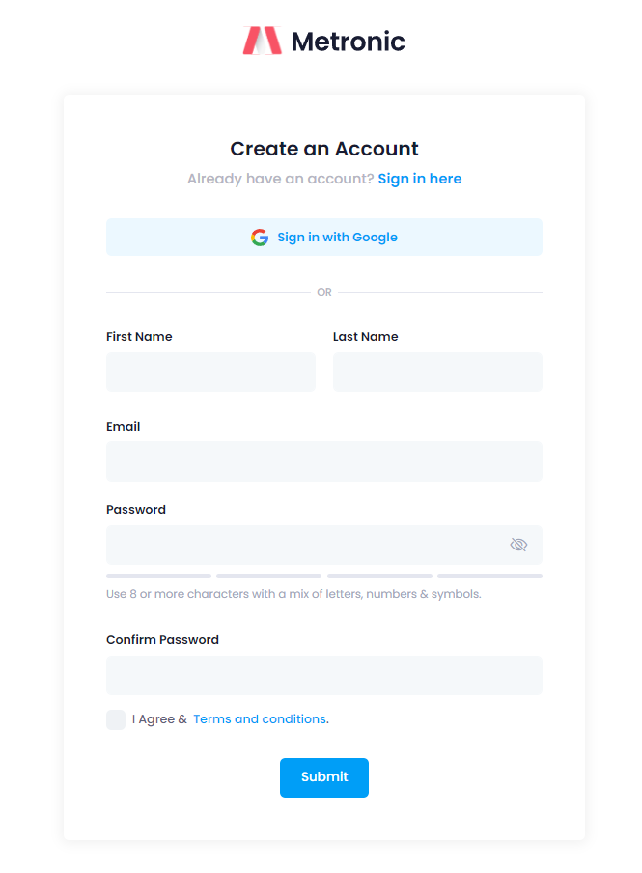

**Function Details:** Show the form to input the account, password, email, name, phone number, address.

The form will validate the input data in real time.

After the user clicks the Register button, the system will request POST /register to check the account and password.

if the account and password are correct, the system will respond with 200 and JSON data.

Otherwise, the system will respond to 400 and JSON data.

if data is 200, the system will redirect to the homepage and allow the user to access the system.

### 1.3 Reset password

**Function trigger:** Click the Reset password button

**Function description:** Allows the user to reset the password.

**Screen layout:**

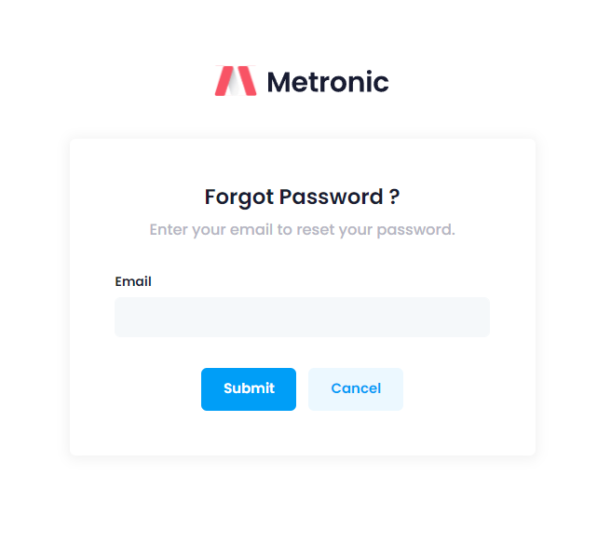

**Function Details:** Show the form to input the account, email and send the email to reset the password.

System will link the reset password page to the email.

link reset password page will expire after 1 hour.

After the user reset the password, the system will redirect to the login page.

## 2. User

### 2.1. User List

* **Function trigger:** Click the button User List from taskbar left.
* **Function description:** This function is for the admin to edit all users from the system.And can search, sort all user lists.
* **Screen layout:**

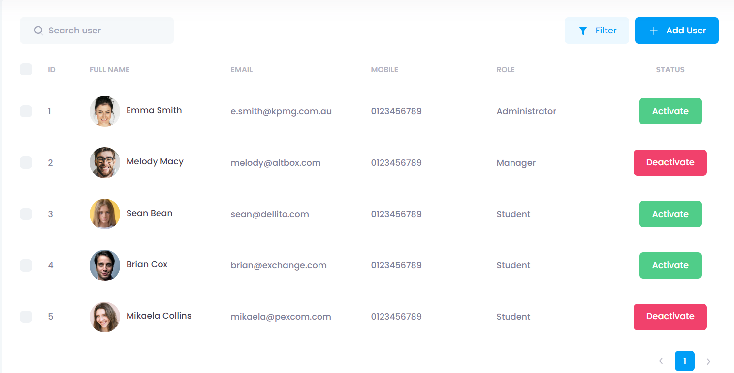

* All users are shown in a table with column matches with user properties.

### 2.2. User Details

* **Function trigger:** Click on avatar or name from User List..
* **Function description:** This screen will show user Details. Include: Id, Full Name, Email, Mobile, Role, Status, Note. And can change any properties when clicking on icon change.
* **Screen layout:**

### 

### 2.3. Change Password

**Function trigger:**

When a user wants to change a password, click on the “Change password” button in the profile screen.

**Function description:**

The system shows the change password form and allows users to change their current password.

**Function detail:**

User must input valid data: Current password must be correct, New password must pass the validation, Confirm password must match new password.

**Screen layout:**

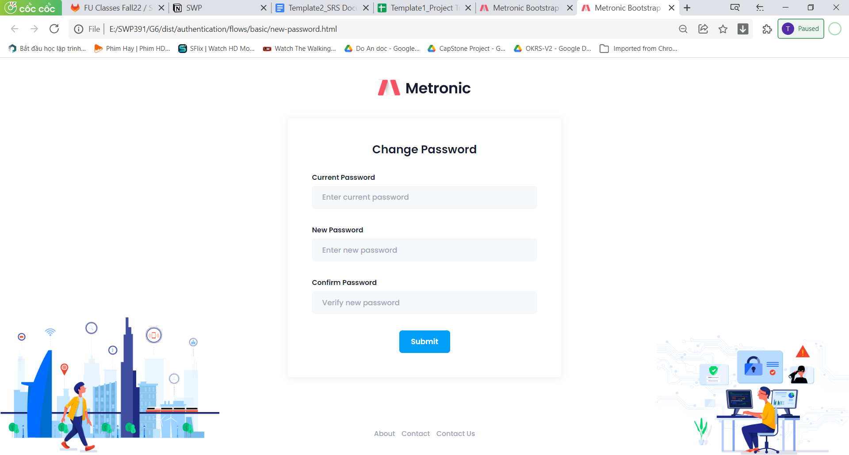

Fig. Change password form

### 

#### 

### 2.4. Setting list

**Function trigger:**

When a user wants to view the setting list, the user must login with Admin authentication.

Click on “Setting” in the dashboard page.

**Function description:**

The system shows the setting list page.

The user can search settings by title using the search bar, can filter settings and sort settings by column.

The user can view setting detail, edit a setting and activate/deactivate a setting.

**Function detail:**

Only an admin can view the settings list.

**Screen layout:**

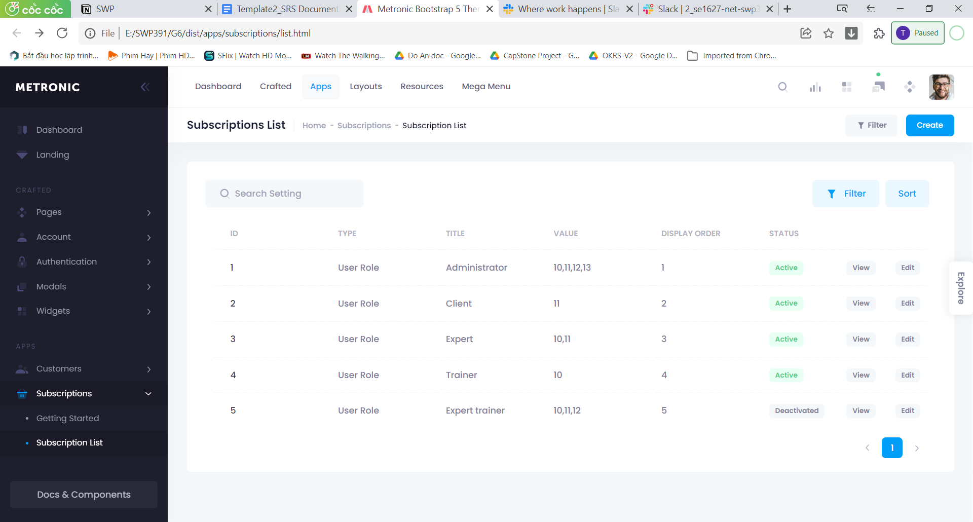

Fig. Setting list

#### 

### 2.5. Setting detail

**Function trigger:**

When a user wants to view the setting detail, the user must login with Admin authentication.

Go to the setting list by clicking on “Setting” in the dashboard page.

Click on “View” on a setting row.

**Function description:**

The system shows that setting detail.

**Function detail:**

Only an admin can view the settings in detail.

**Screen layout:**

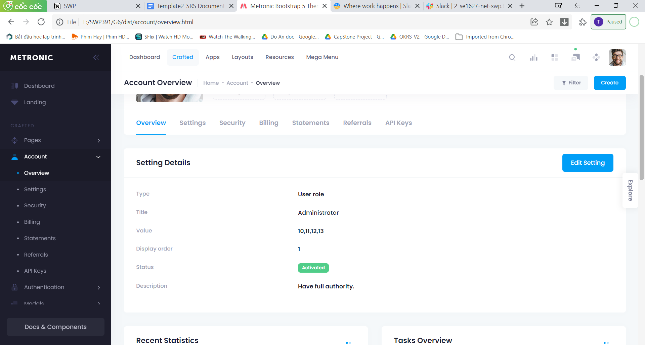

Fig. Setting details

### 2.6. User Profile

· Function trigger : Click upper right icon avatar of user. Then Click My profile

· Function description: Allow the user to change the avatar, full name and view others (email, role) o The client can input/change his/her mobile, address, company, position o He/she can link to the Password Change screen below

· Screen layout: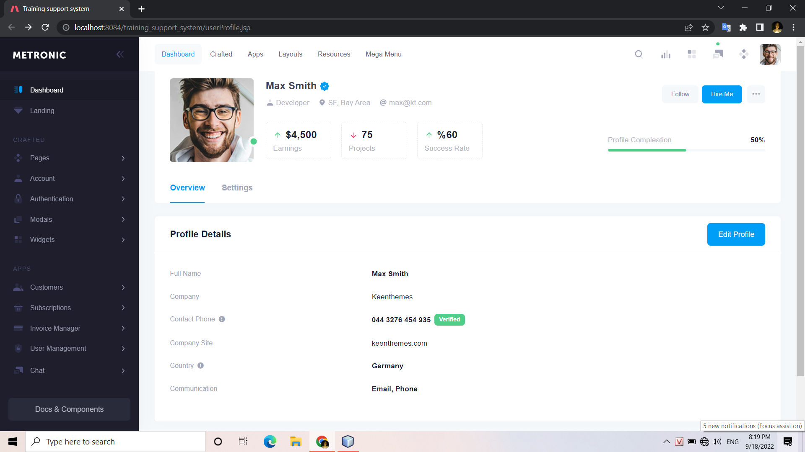

· Functional detail: The user can change information about the profile and can update this profile.

#### 

## 3. Web Contact

### 3.1 Web Contact List

* **Function trigger:** Click on Web Contact List from left taskbar.
* **Function description:** It will show all contact details that User had sent to the system. Include: Name, contact, message, response.

### Screen layout:

### 3.2. Web Contact Details

**Function trigger:** Click the contact that customer sent to view details.

**Function description:** The system will display messages customers sent, and the admin can view or reply to them.

**Screen layout:**

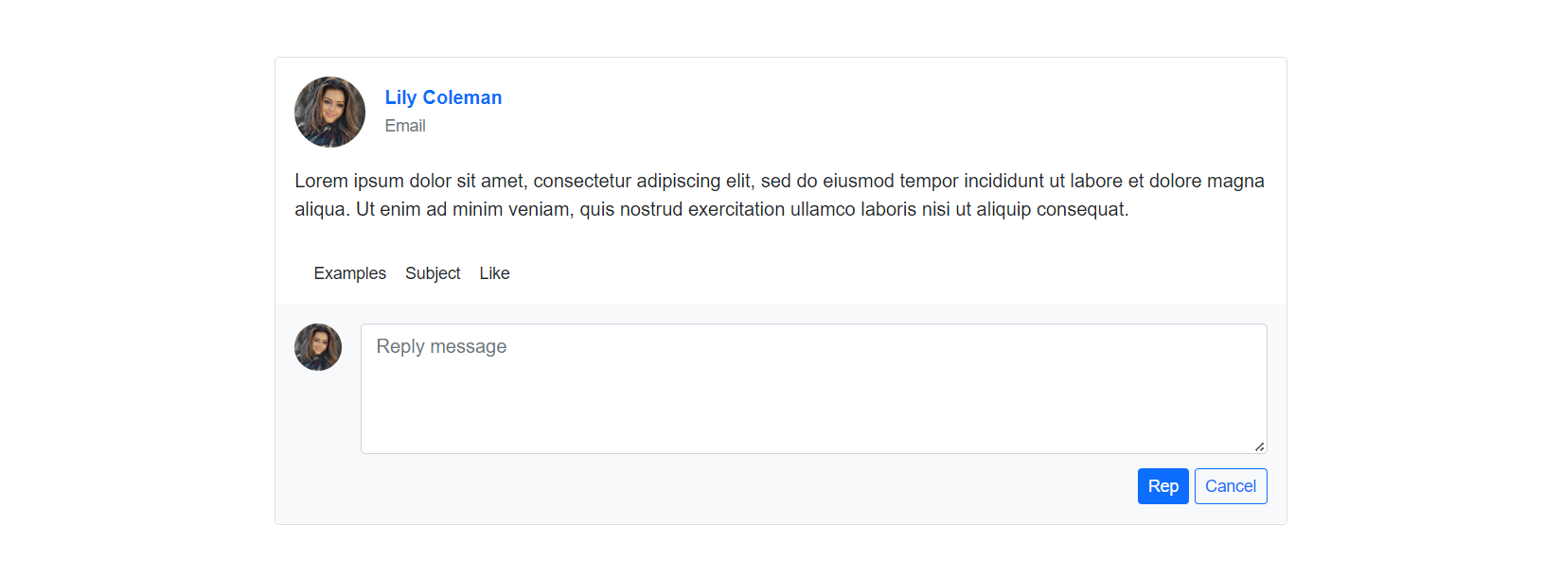

**Function Details:** Show message customers sent, and about customer’s email, which relate the messages like subject,.... Form reply message for admin. Click rep to reply, cancel to quit.

## 4. Subject

### 4.1 Subject List

**Function trigger:** Show list of subjects by paging.

**Function description:** The system will display the subject name, some information about the subject, and button Read More.

**Screen layout:**

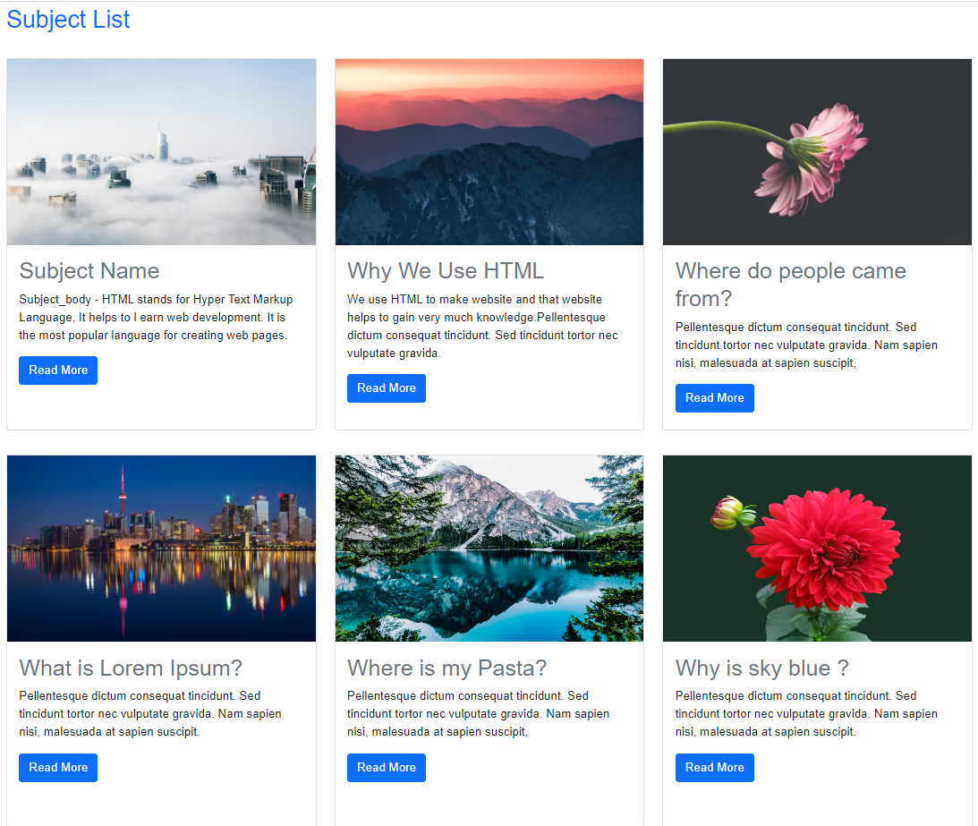

**Function Details:** Subject list screen displays list of subjects by rows and column, each screen shows 6 subjects, if more than 6, customer can next to page 2 to view more subjects. Read more buttons to view details of the subject.

### 4.2 Subject List Details

**Function trigger:** After click Read More button in Subject List Screen, that screen will be displayed

**Function description:** The system will display details of that subject.

**Screen layout:**

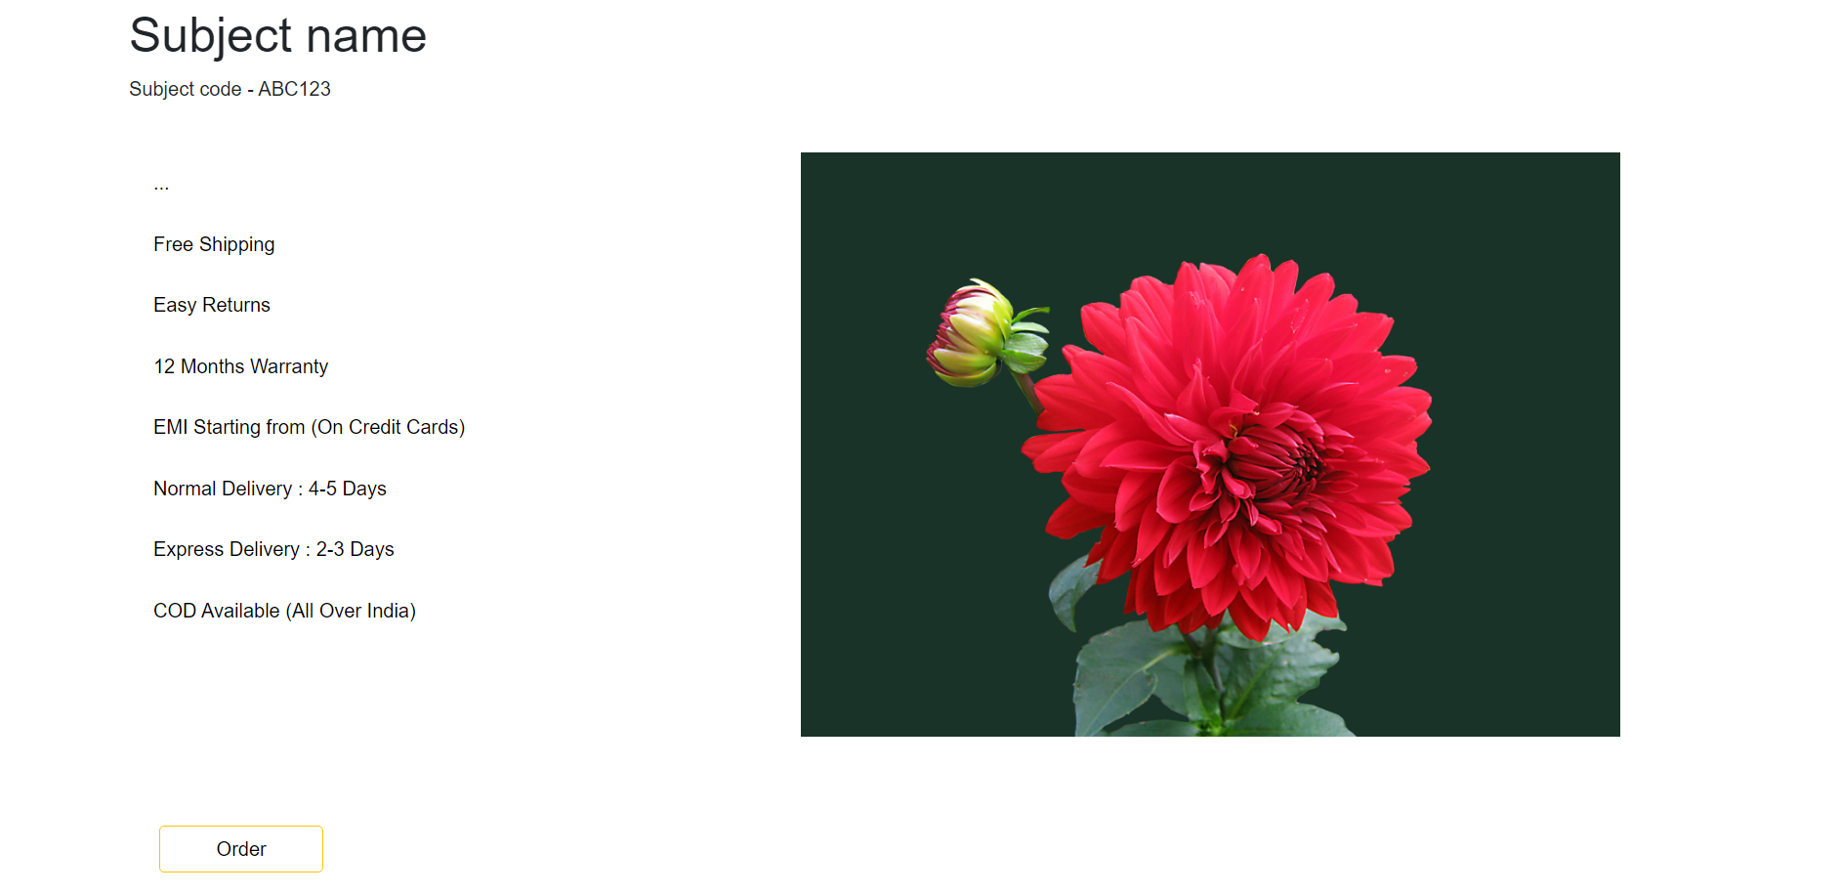

**Function Details:** Subject details screen displays all information about that subject. Click the order button to regist learning subject.

## 5. HomePage

### 5.1 Design Homepage

· Function description: Show the static contents and include the web header & footer as in the Mockups sheet Allow the guest to submit the contact information in a chosen category.

· Screen layout:

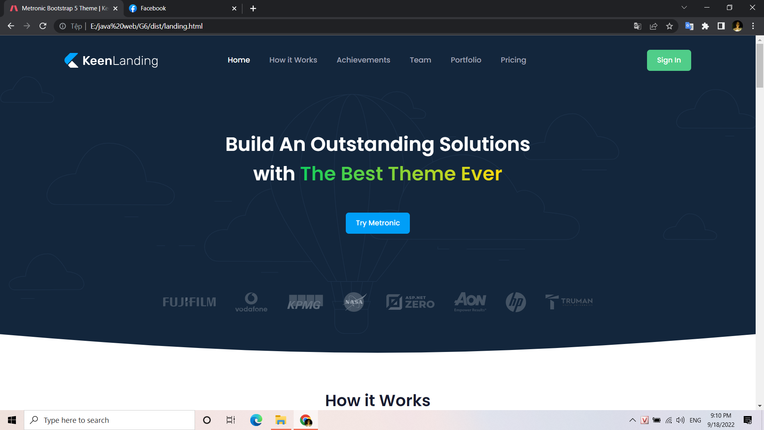

### 5.2 Design Dashboard

· Function description: Show the sample dashboard information where the data are taken from below APIs (ref<https://morioh.com/p/57a8d79967b5> for more details) the page include common Admin Header, Admin Footer, and Nav Bar as in the mockup screen.

· Screen layout:

